Lab 7
By: Anthony Garcia

Exercise 1

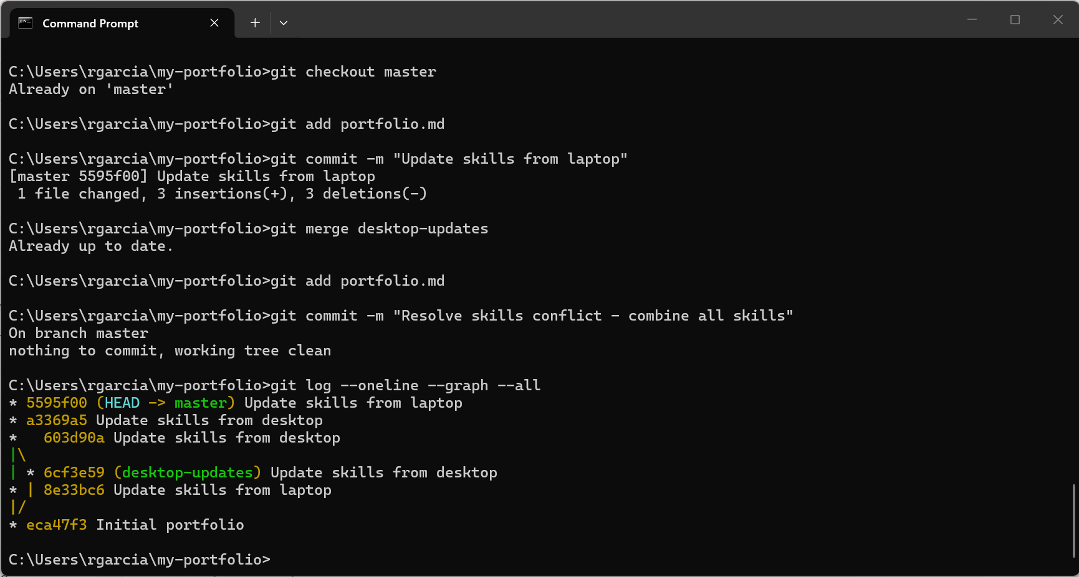

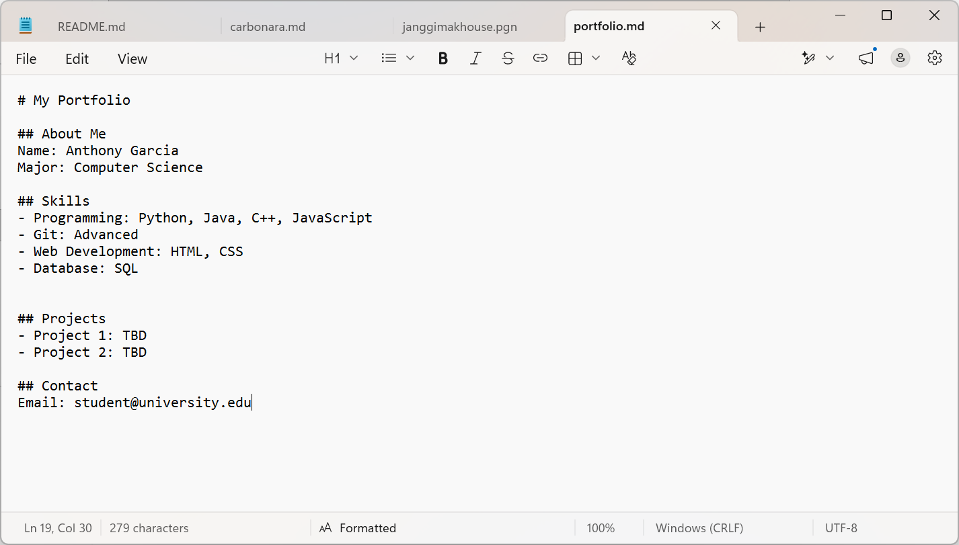

Reflection Questions
1. Why did the conflict occur?
The conflict occurred because both branches changed the same Skills section in portfolio.md with different content.
2. What would have prevented this conflict?
Pulling the latest changes before editing and coordinating changes between devices could have reduced the chance of a conflict.
3. In real life, how do you avoid conflicts when working on multiple devices?
Commit changes regularly, push them to the remote repository, and pull the latest changes before starting work on another device.
4. What was the most challenging part of resolving the conflict?
Combining both versions of the Skills section without losing information.
5. How did Git help you identify where the conflict was?
Git displayed an error message and added conflict markers to show the differences between the two versions.

Exercise 2

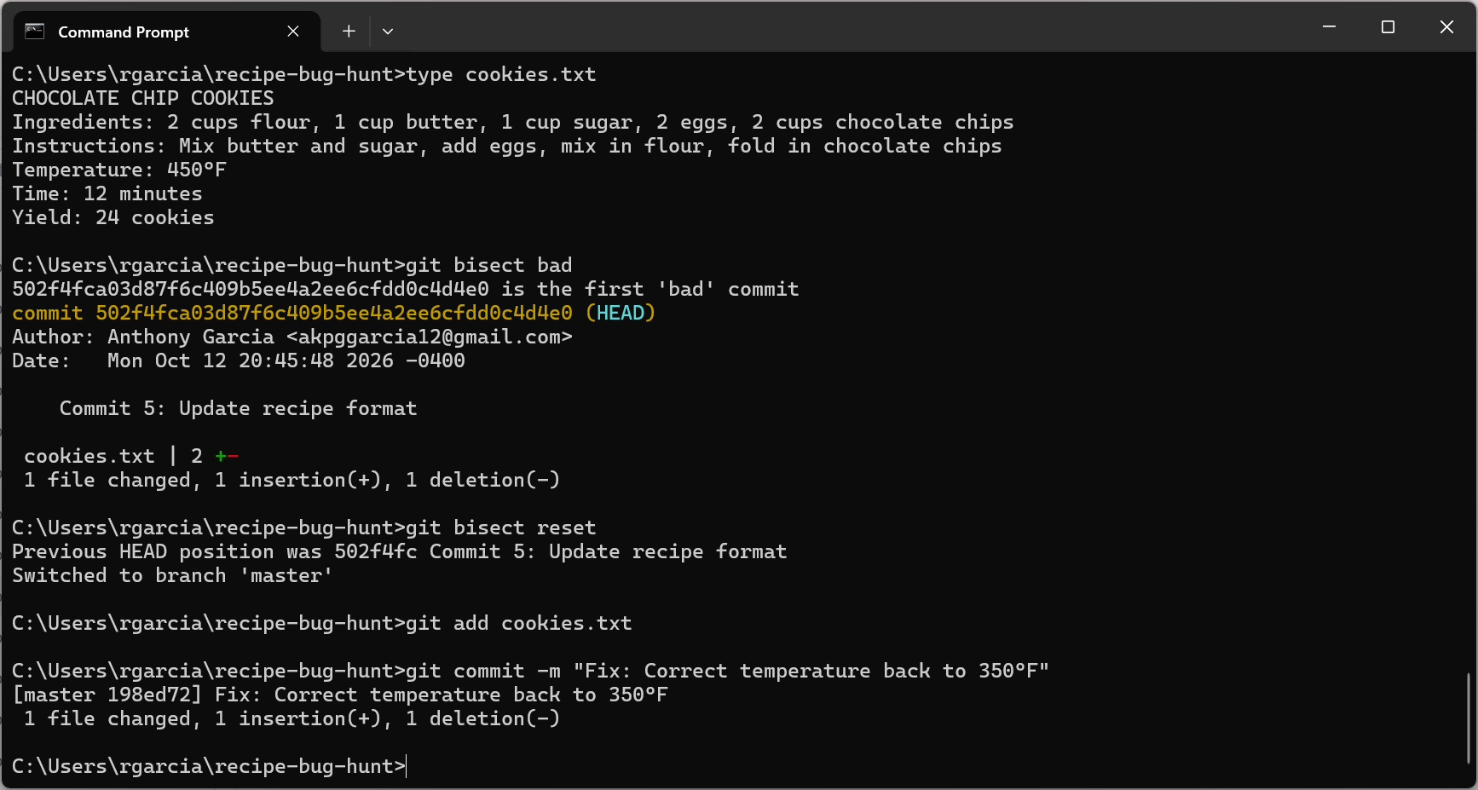

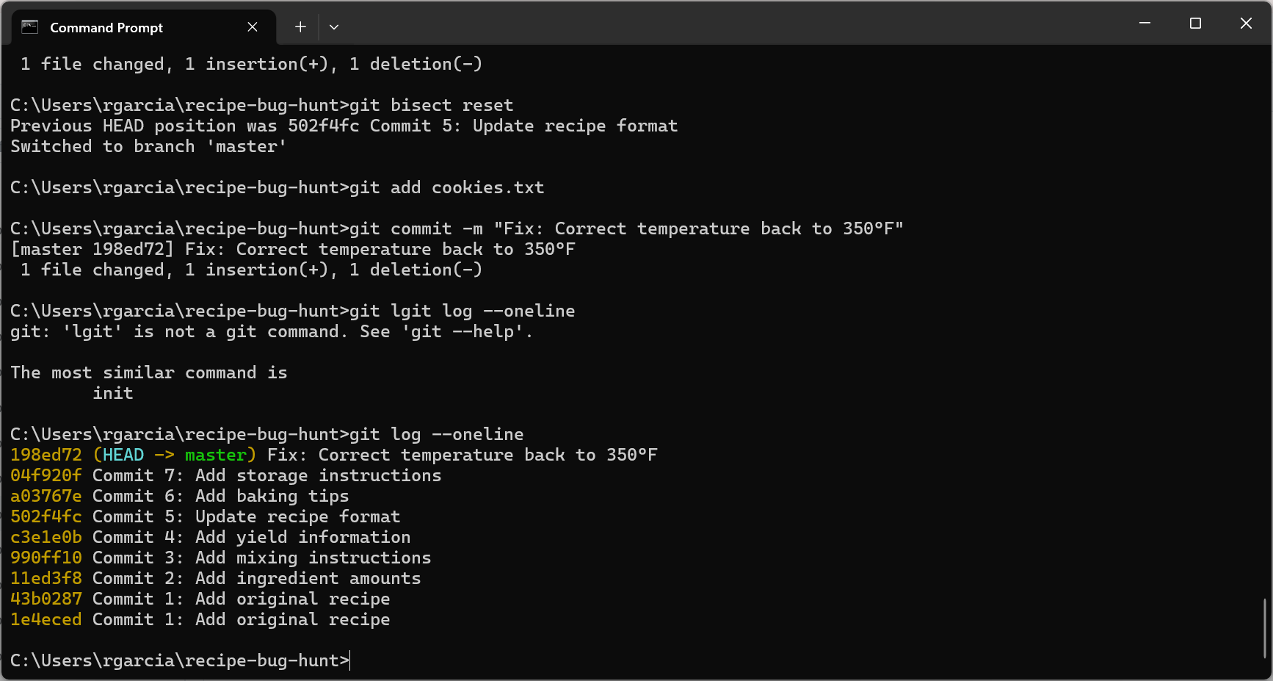

Git Bisect Reflection Questions
1. How many times did you have to check the temperature before Git found the bug?
3 times.
2. If you had 100 commits instead of 7, about how many checks would bisect need?
Git bisect would need about 7 checks to narrow down the problematic commit among 100 commits. With 1,000 commits, it would need about 10 checks because binary search eliminates approximately half of the remaining commits each time.
3. How is bisect different from manually checking each commit with git checkout?
Git bisect is more efficient because it uses binary search to narrow down the commit range. Git checkout checks for every single commit which is longer.
4. When would git bisect be most useful in real projects?
Git bisect is most useful when a bug appears in a large project with many commits. It saves a lot of time by narrowing down the range.
5. What information do you need to start a bisect session?
Whether the commit was good or bad so it can get to the next step.

